Phase 1 — Empathy Map Canvas
Implement Client Script & UI Policy (Incident)
01 October 2026 | Phase 1 | SWTID-2026-4755
Field | Project value
Date | 01 October 2026
Team ID | SWTID-2026-4755
Project Name | Implement Client Script & UI Policy (Incident)
Phase 1 focus | Understand the agent experience and administrator needs behind the Incident controls
1. Persona and context
Primary persona: a service desk agent creating or updating an Incident during an active queue. The agent is expected to move quickly, but must still provide enough information for routing and resolution. Secondary persona: the ServiceNow administrator responsible for making the rule predictable, maintainable, and testable.
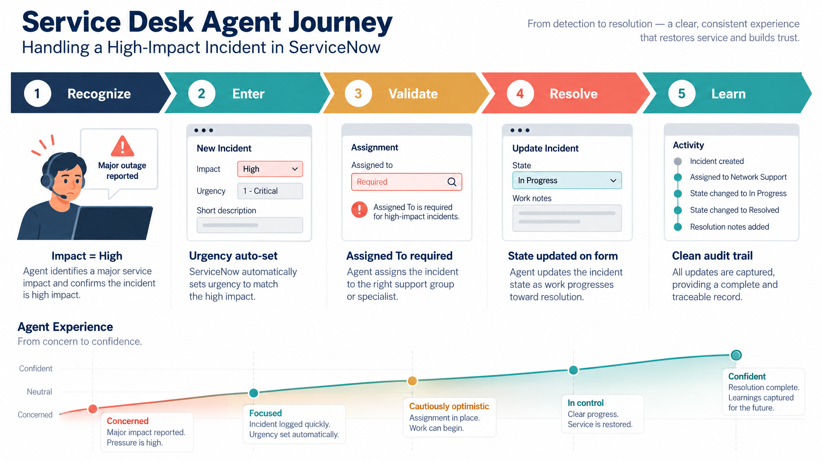
Generated project visual: service desk agent journey from recognition to controlled resolution.
2. Says
• “I need to record the Incident quickly.”
• “Tell me exactly which field is missing.”
• “If the Incident is high impact, set the urgency for me.”
• “I should be able to understand why a list edit was blocked.”
• “When Impact changes, the form should not keep old restrictions.”
3. Thinks
• High-impact work may affect many users and should not be routed incompletely.
• A silent or generic failure will slow triage.
• The system should automate obvious decisions but leave meaningful decisions visible.
• List editing is convenient, but State changes may need the full form context.
• A rule that is difficult to explain will be difficult to trust.
4. Does
• Opens Incident → Create New or an existing Incident.
• Selects or changes Impact.
• Checks Assignment group, Assigned To, Urgency, State, and description.
• Attempts to submit the record.
• May edit records directly in a list when working through a queue.
• Uses the full form when an action requires context or validation.
5. Feels
Moment | Likely feeling | Design response
Before Impact is set | Focused but time-pressured | Keep routine form behavior lightweight.
Impact becomes High | Concerned about completeness | Activate visible mandatory/routing controls.
Urgency changes automatically | Reassured if explained | Show an information message.
Save is blocked | Frustrated if unclear | Show a field-level error naming Assigned To.
List State edit is blocked | Surprised or annoyed | Explain that the Incident form is required.
Impact is reduced | Relieved | Reverse temporary restrictions automatically.
6. Pains
• Remembering multiple high-impact rules while responding quickly.
• Incomplete records creating rework or delayed ownership.
• Unclear error messages that do not identify the next action.
• Unexpected restrictions that remain after the Incident becomes lower impact.
• Unsafe list edits changing workflow state without sufficient context.
7. Gains
• A dependable high-impact record at the first save.
• Automatic urgency alignment.
• Clear field-level and action-level feedback.
• Predictable reversibility.
• Confidence that list editing cannot bypass workflow safety.
• A maintainable configuration the administrator can test and explain.
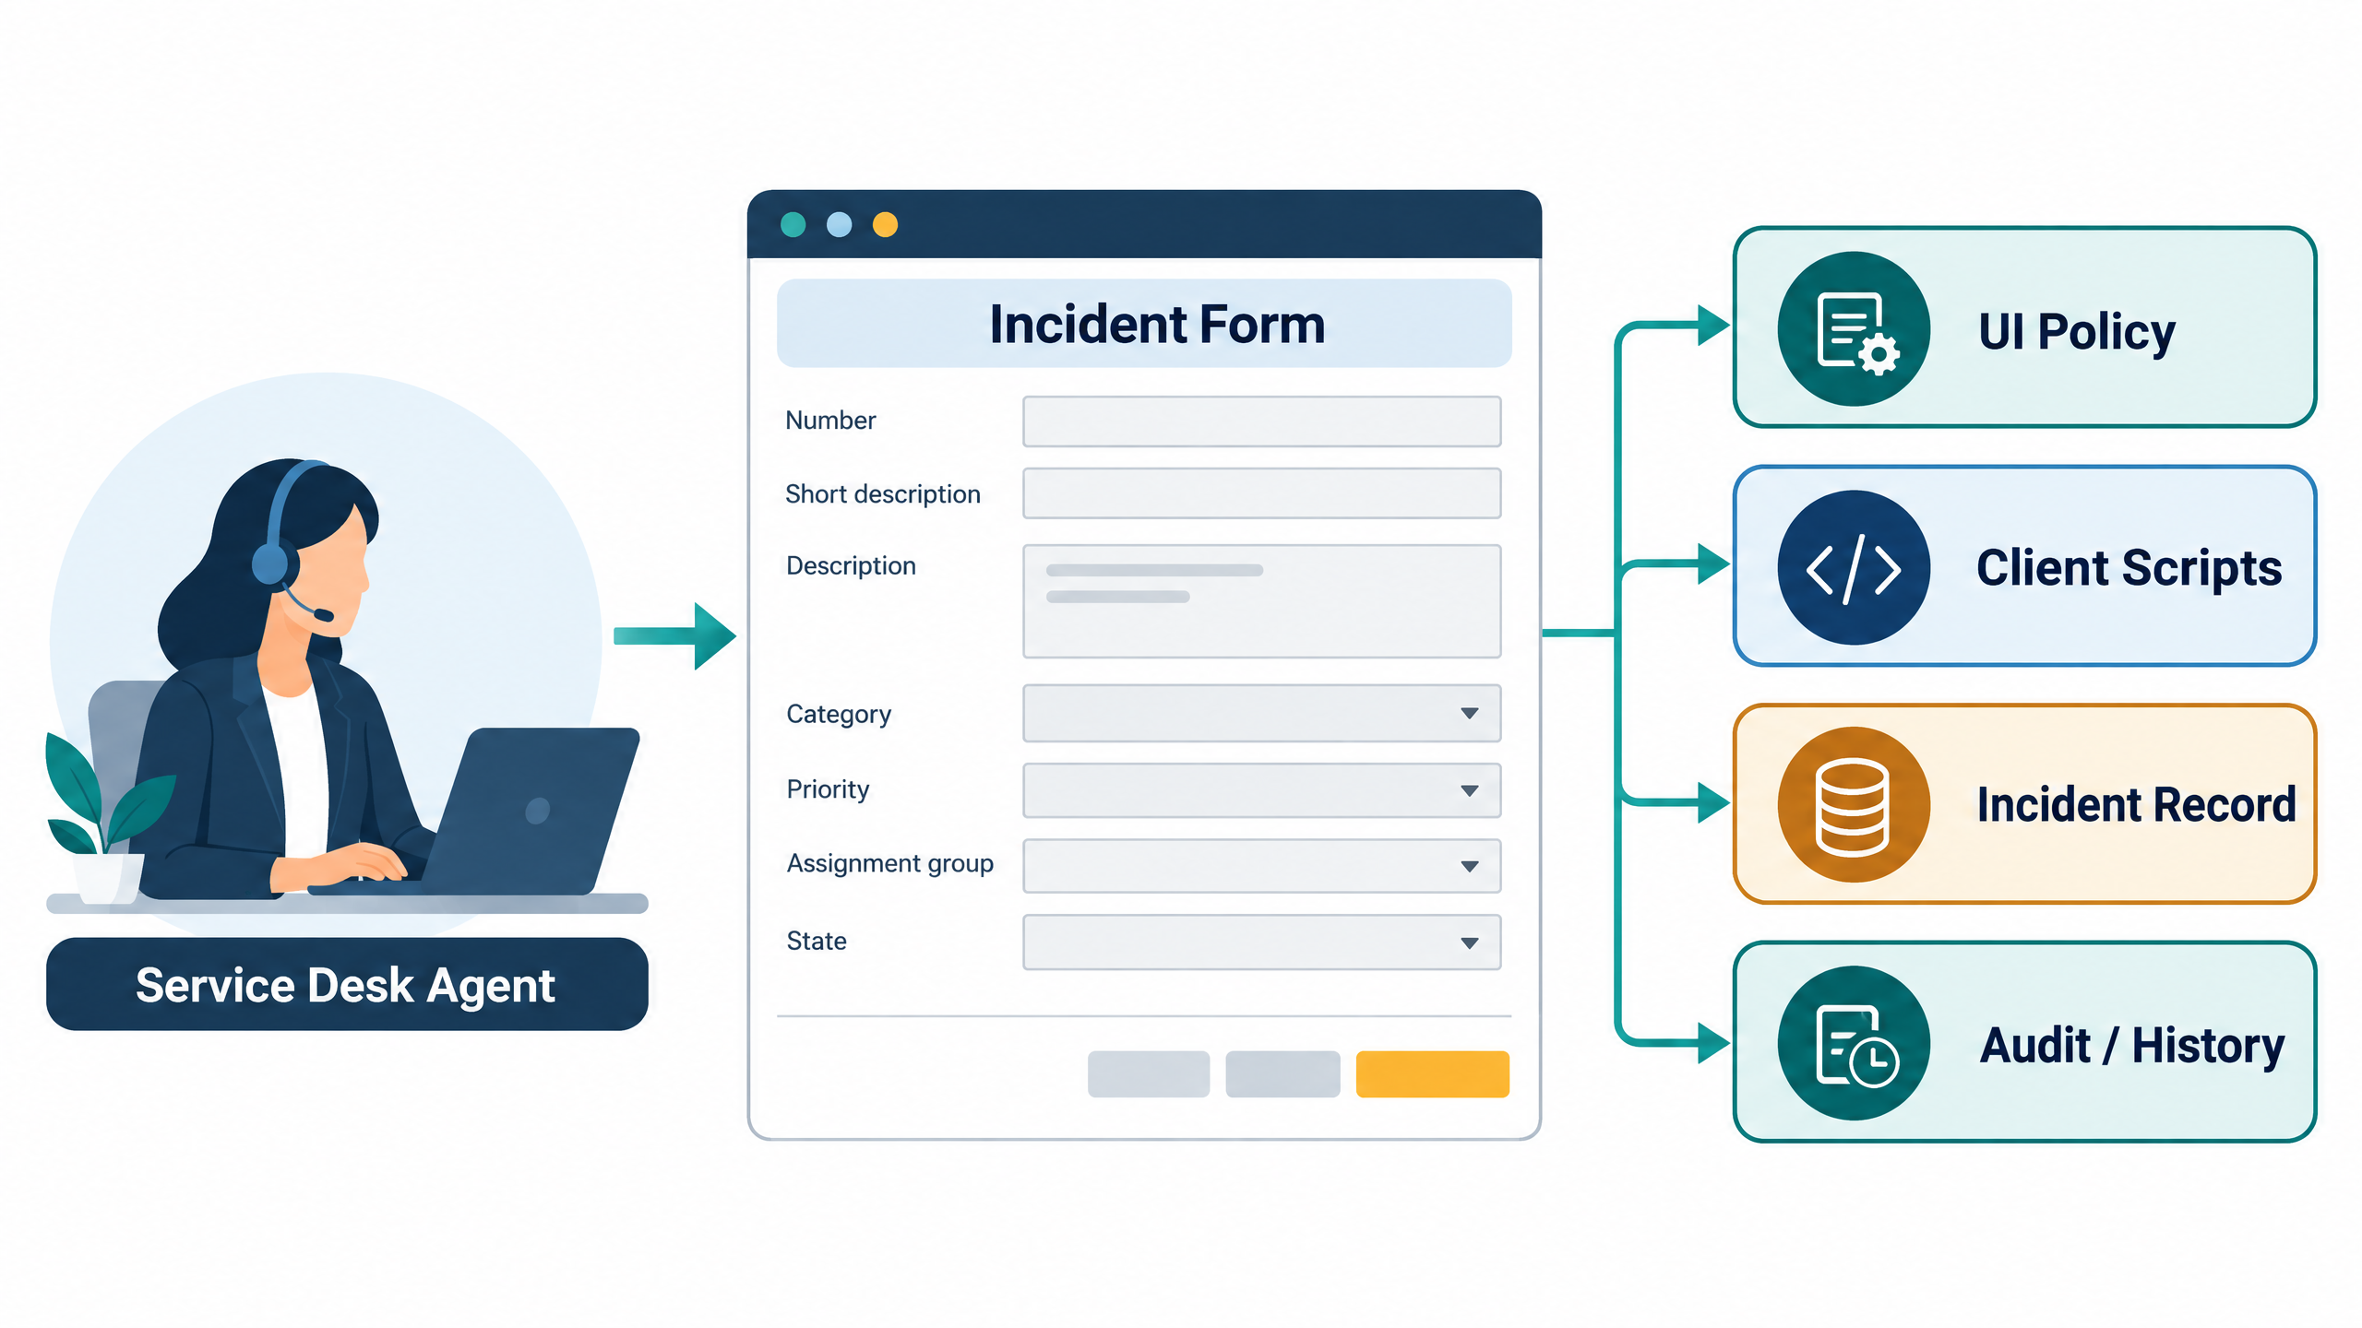
Generated project visual: the user experience is supported by a native ServiceNow policy and event-control layer.
8. Empathy insight translated into requirements
Insight | Requirement implication
Agent needs immediate guidance | Use UI Policy actions and g_form messages at the relevant event.
Agent needs a clear correction path | Use showErrorBox on Assigned To and an alert for State list edits.
Administrator needs predictable scope | Bind controls to Incident and explicit fields/events.
Users need normal behavior after risk decreases | Set Reverse if false = true and test the transition.
Operations need trustworthy records | Validate before submit and protect State changes.
9. Phase 1 empathy conclusion
The empathy map confirms that the solution should not be a blanket restriction. It should be conditional, explainable, reversible, and aligned to the agent’s moment of risk. The selected ServiceNow UI Policy and Client Script pattern fits those needs while keeping the platform-native workflow intact.

